**AWS Developer Associate**

Lab Guide

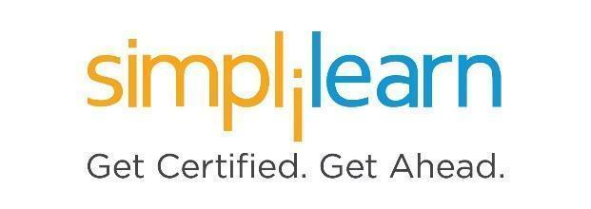

**Note: The screenshots used in Step 1 are only for your reference. Your LMS may look different depending on your course content.**

This section will guide you to:

* Use labs for executing all the demos included in this course

This lab has two subsections, namely:

1. Starting practice labs on LMS
2. Using the services required for this course in Amazon console

**Step 1:** Starting **Practice Labs** on LMS

* Login to Simplilearn LMS
* Go to the respective course

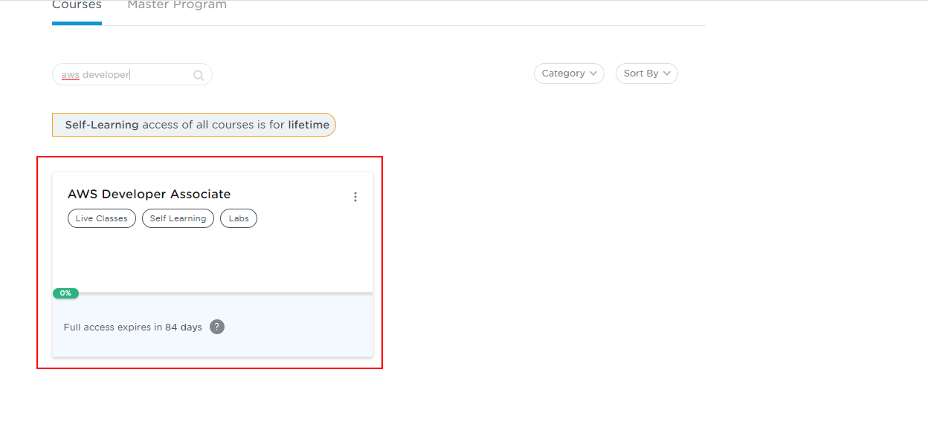

* You will see the course TOC page. Click on **PRACTICE LABS.**

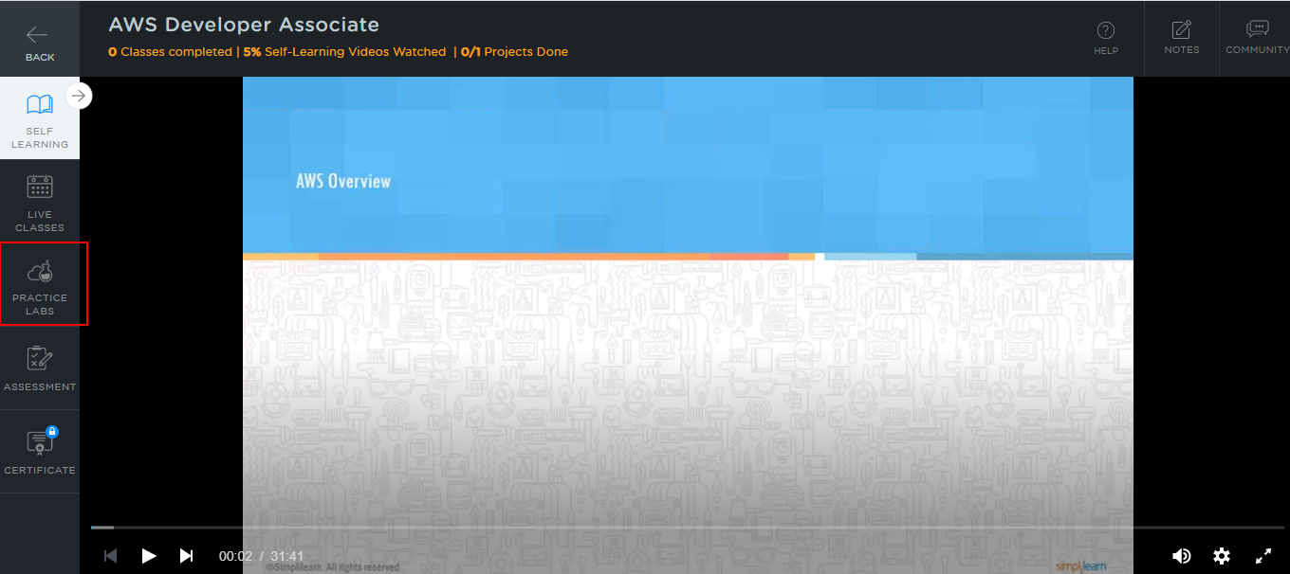

* A new window will open. Read the instructions and click on the **LAUNCH LAB** button**.** This will launch the practice labs for this course.
* In the next window, select AWS Web Console and click on the Auth URL, which will direct you to the Amazon console in a new browser tab.

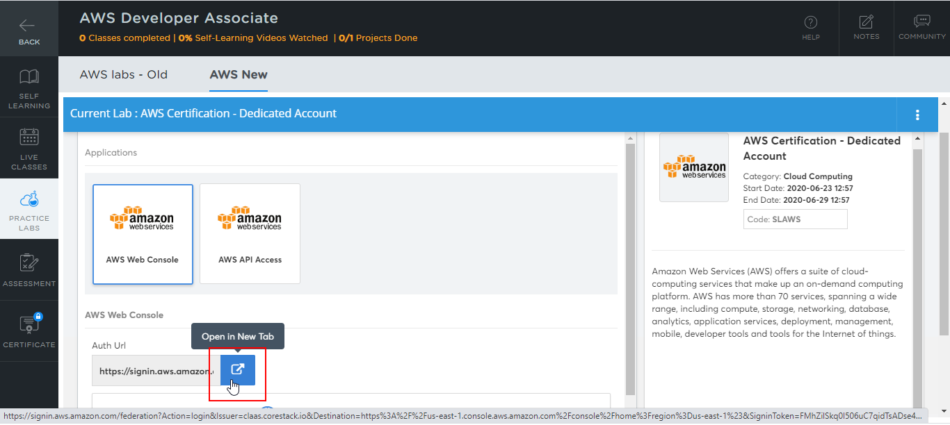

* You will be able to access the required services and resources in this console.

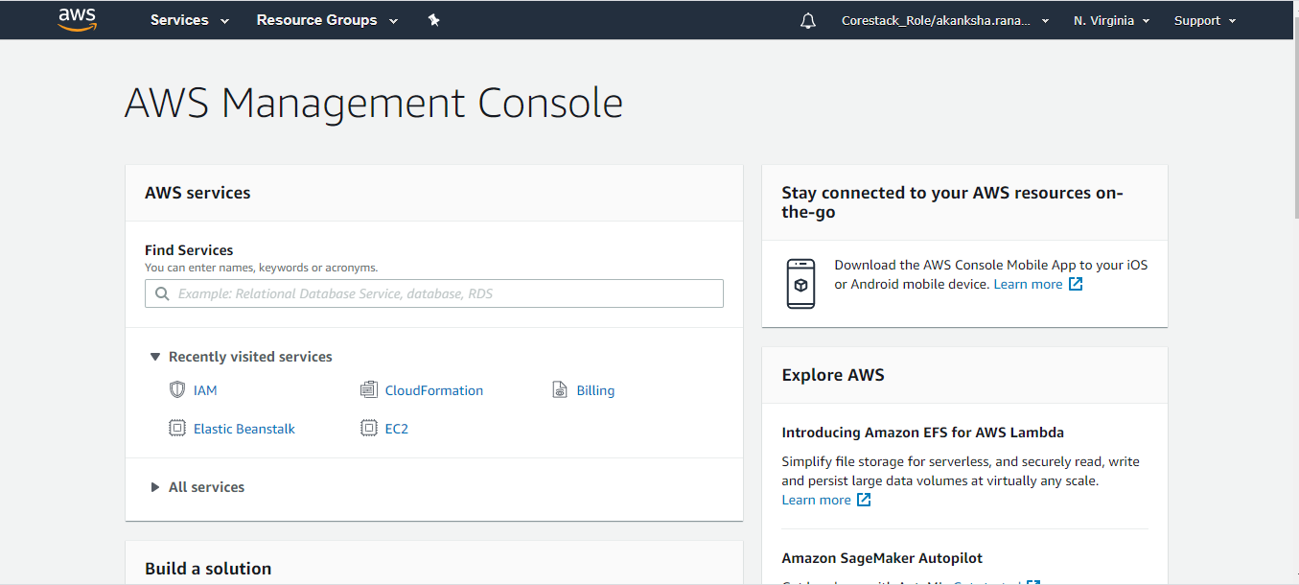

**Step 2:** Using different services in the Amazon console

* Keep in mind the following guidelines while making use of the required services in the AWS console:
  + Set the region to **us-east-1 or us-east-2**. Other regions may result in failure for most actions
  + Use **t2.micro** type EC2 when creating EC2 instances
  + Use **Standard, GP2** EBS volume type and set the size **less than or equal to 30 GB**
  + Use **db.t2.micro** RDS database class while creating RDS instances